**ICARUS SOFTWARE CHALLENGE(BY JEEVAN THANU)  
  
APPROACH:-**

Algorthims in the code:-

1.Matched filtering

2.Symbol Timing Recovery

3.BPSK demodulation

4.Viterbi Algorithm

5.Reed-Solomon Decoding(RS(15,11))

6.Kay’s Frequency offset simulator  
7.CFO Correction(Complex Exponential rotation)

8.Costas Loop(Carrier/phase recovery)

9.Bit Error Rate(BER) calculation=no. of bit errors/total bits compared

**METHODS:-**

1.Digital modulation/demodulation---Transformation of bits to waveforms(consists of BPSK mapping,matched filtering and symbol training)

2.Error correction coding –To detect errors caused due to noise and correct them.(consists of convolution and reed Solomon)

3.Synchronization—consists of CFO estimation,Doppler correction and costas loop.

4.Performance analysis –To compare the obtained result with the performance threshold .If it matches then the code is working.Thus we compute ber,csv logging,and plotting of ber vs snr graph,plotting of constellation diagrams and doppler diagrams.

**CHALLENGES:**1.First I was getting an error of no value of RS PASSED .So I gave the value as RS(15,11) and it was working.And even in the challenge table it was specified that we had to take RS values as 15,11.

2.When I copy and pasted the code in python(phase1-4 code)..and ran it .A empty excel file was getting generated. In the ICARUS folder.Then after debugging and many prompts I realised that the all the phase folders must be extracted in the location where the excel file is getting created which is the ICARUS folder.Then after I ran the code still it was not working.Then I realised that the elements like 0db,5db,10db,15db were directly getting extracted into the ICARUS folder.Then I created folder for each phase ..and gave it the same name as in the code.Then I put all the respective elements of the phases inside their respective folders.

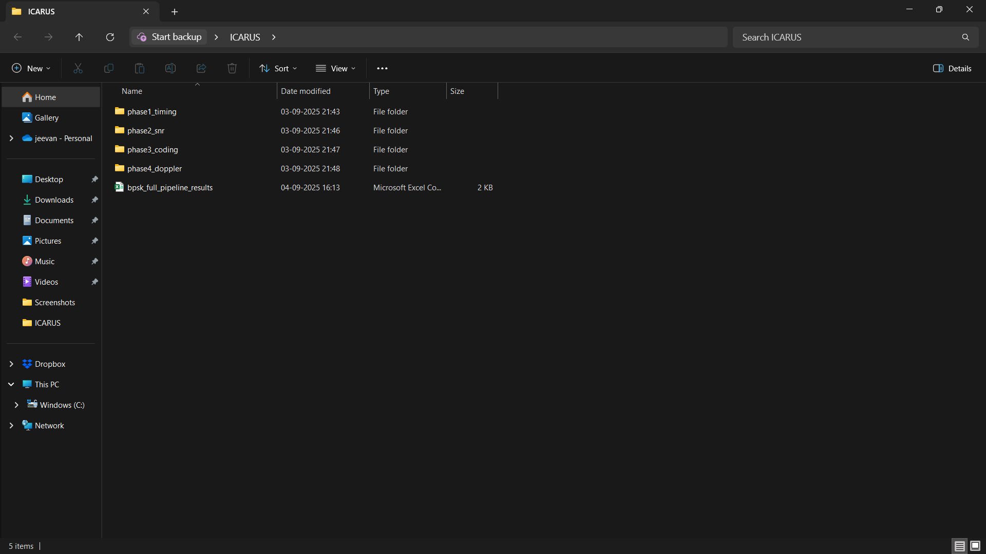

And then the excel sheet with values was getting generated.

3.When I was generating codes for phase 1-4 and executing on idle python.It was not at all running after a couple of times .And it showed an permission denied error.Then I realised that after you execute the code one time and when you open the excel sheet ,u must close it cause windows cant replace or change the new values in the excel sheet if it is open.

4.The values generated in the excel sheet was not matching with the challenge table provided.After many prompts I realised that I have to go back to the original code after I added RS(15,11) as during that run phase 1 and 2 were working.Then after woring on that phase 3and 4 were working but 1 and 2 had errors.I was always getting naïve result and not the performance threshold.Then I debugged each and every phase individually and after I tuned the code by many prompts and then when I compared it to the challenge table ,it was working and the values were matching with the performance threshold.

3.Then I used chatgpt to plot the ber vs snr graph.Then I realised that I could plot the ber vs snr graph through a code in the main code itself.Then after many tries I realised that I couldn’t get accurate values for the grapgh through the python code as it was unable to take all the realtime data which was getting created in the excel sheet and plot the graph.The graph shape was also not the same.Therefore I decided to go ahead by feeding the entire excel sheet to chatgpt and come up with the ber vs snr graph.As it was more accurate.

**IMPLEMENTATION NOTES**

**DESIGN DECISIONS  
1.Use of tkinter so that the user can choose the root folder interactively.**

**2.Synchronization-matched filter and symbol timing loop are used**

**3.The constellation diagrams and doppler diagrams are drawn using the data in the dataset folders.**

**4.Use of convolution coding and reed Solomon in phase 3(channel coding.**

**5.In phase 4 carrier frequency offset and doppler is implemented by kays frequency estimator (by cfo estimation) and the costas loop.**

**6.Pipeline integration – each phase is independent and results from all the phases are collected into a CSV file at the dataset root.**

**7.BER vs SNR graphs;BER logging,Constellation diagrams and doppler visualization.**

**ASSUMPTIONS:**

**1.The dataset folders has the files rx.npy and meta.json**

**2.The bitstream is generated randomly between 0 to 1 ,for BPSK. And RS is 15,11.**

**3.Dataset is error free.**

**4.Channel is AWGN**

**6.CFO estimation is realistic**

**7.Only BPSK supported.**

**8.And Other minute assumptions**

**LIMITATIONS:**

**1.Only BPSK supported**

**2.Only AWGN modelled**

**3.Requires clean bits**

**4.Dataset should have consistent folder structure.**

**5.The data for ber for the plot of ber vs snr cannot be recovered realitime as it will be less accurate and will check very less values.**

**6.And other limitations**